Description | My friend is obsessed with Miku and recently hidden messages. They sent me this as their first meme.
Files | Miku.jpeg
Hint(s) | 1) Not all embedded messages are the same, maybe look into another webpage.  2) Have you seen this thing that mimics spam? My last DnD character died trying to eat from the can...
Walkthrough | Simple start. Look for a Steganography Decoder  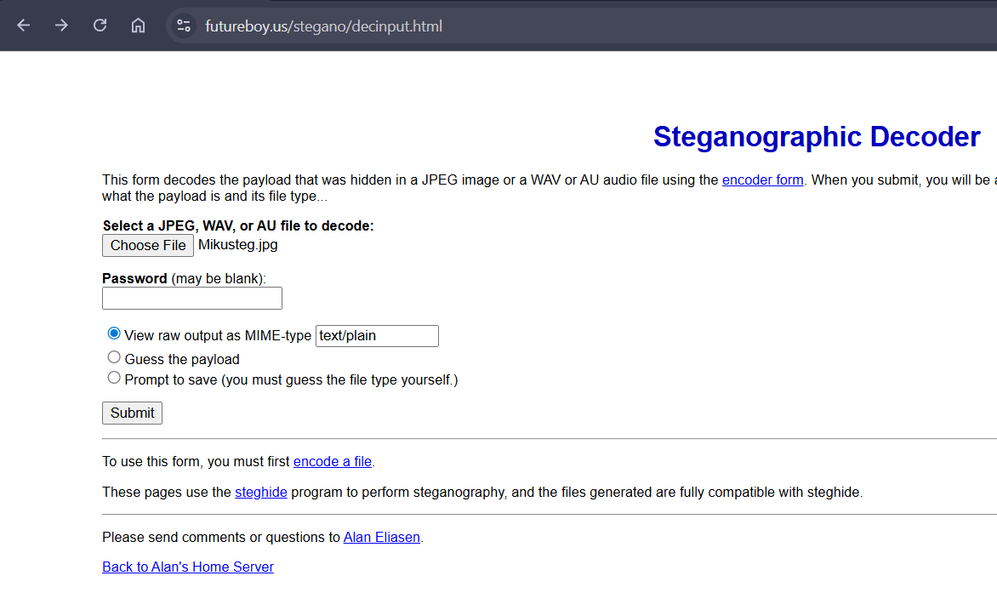  Pressing ‘Submit’:  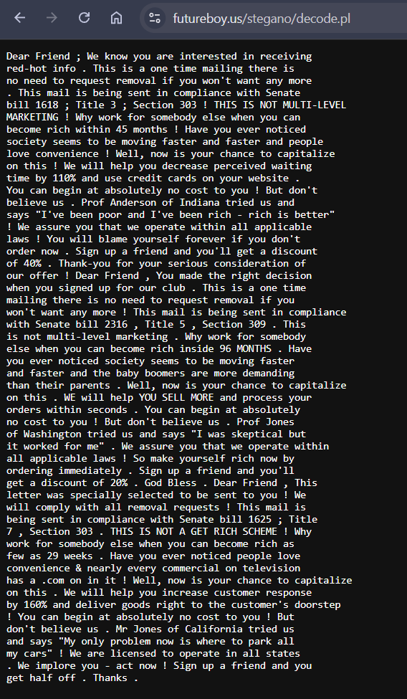  Is there some way this could be hiding the flag?  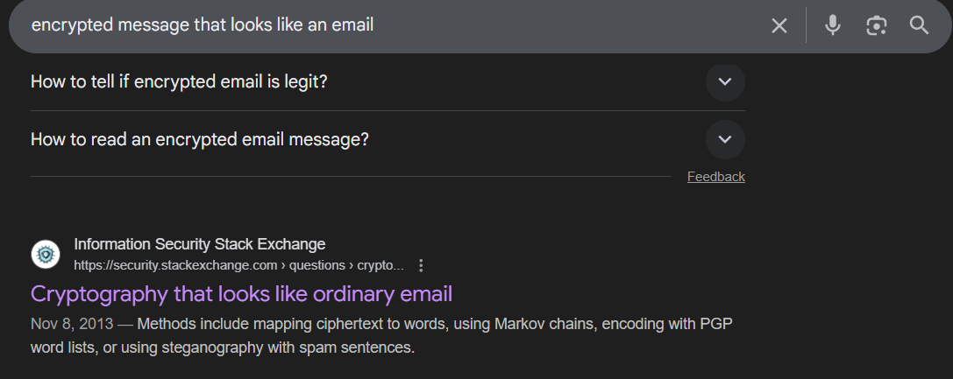  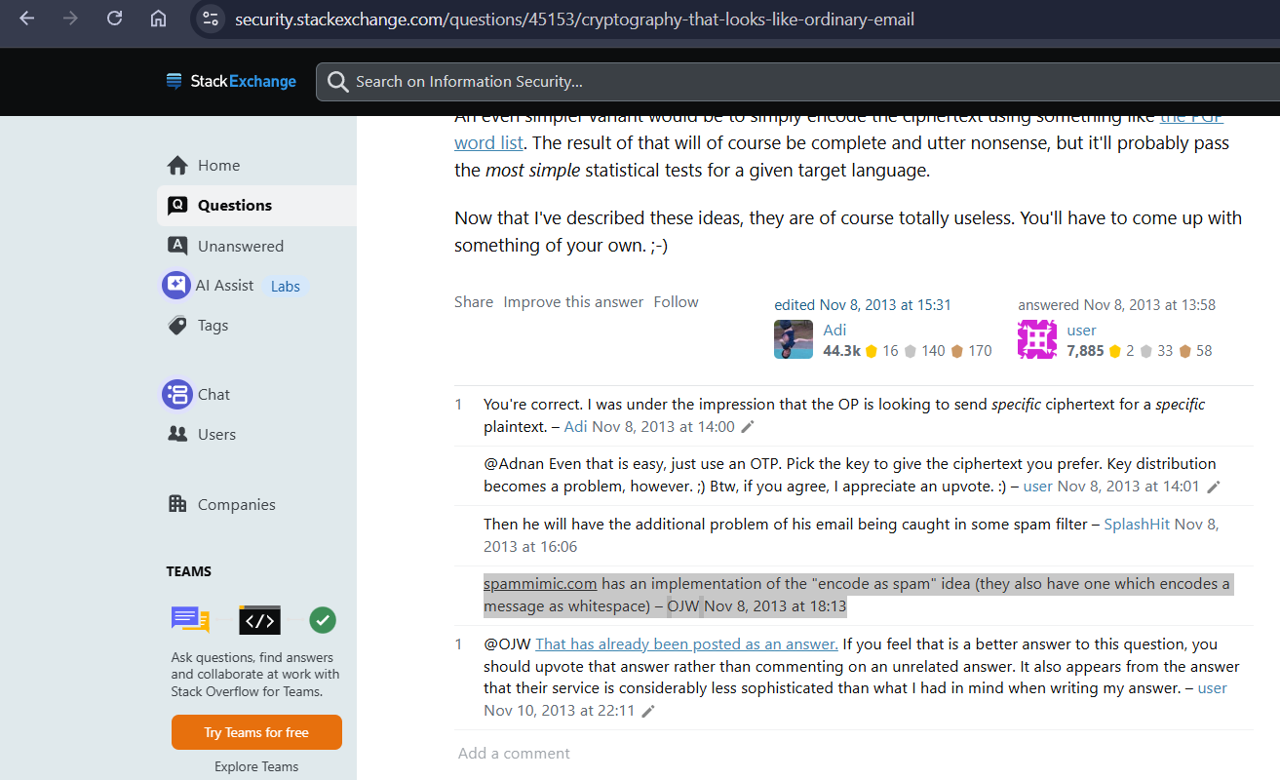  Came across this webpage called ‘spammimic.com’  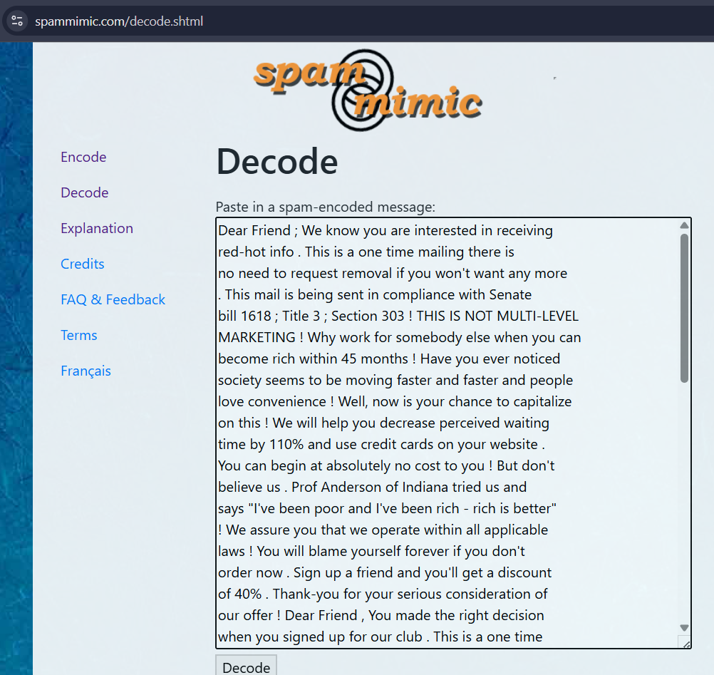  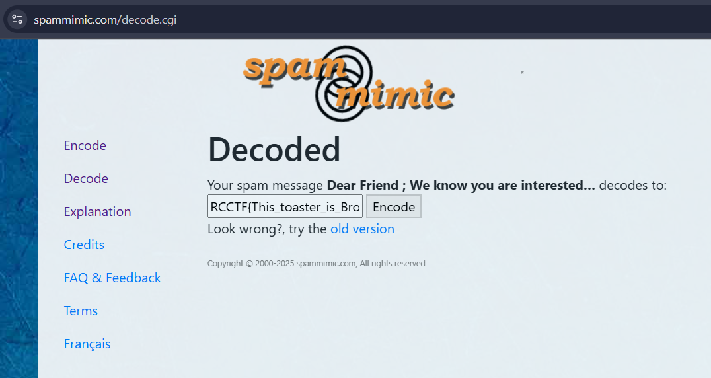  And there’s the flag.
Flag | RCCTF{This_toaster_is_Broken} – Case Sensitive

